01/05/2020

**Department Website**

**My Suggestions**

The design is sleek. It’s good work. A few suggestions to improve the look and the content :

1. In the home page, in the introduction, remove the first two lines. They are obvious.

2. In the last two lines, replace “the vast range of research” by “the teaching and research work”. Avoid the repetition of “learn about” in the next sentence.

3. In the main body of the introduction, include the names of the two research areas in the dept.

4. We can add *Our Motto* before Dyson’s words.

5. In the title, let’s try to give one space between each letter in “DEPARTMENT” and “PHYSICS”

**D E P A R T M E N T *of* P H Y S I C S**

6. Let’s change the background of the title. The black and white look is good. May be some equation on a black board will be suitable. For example :

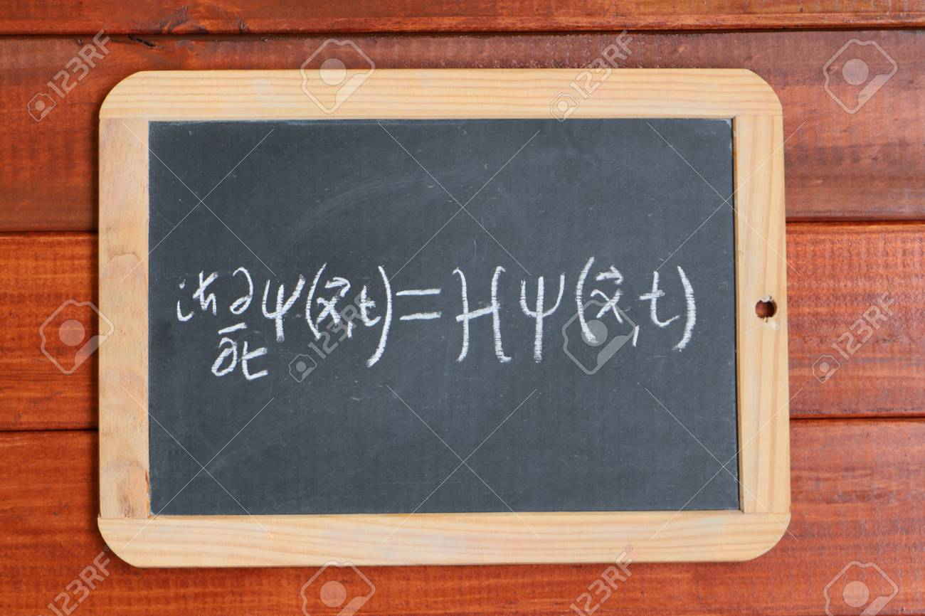

Make the background image slightly blurred, not as blurred as in the present background.

7. The logo of the college should be more visible on the home page.

8. Contact details of the Department should be included in the home page. Postal address and Email ID.

9. Shall we give the phone number and Email ID of the faculty members in the concerned section ?

10. I think the Student Support Programmes should be in the section on Academics, not in People. It can be given after the Achievements.

11. “Results”, not “Result”.

12. “Publications”, not “Published”.

13. In my publications, the first 5 ones should be under International Journals, the next two, under national journals. Please remove these two papers in national journals, they are not relevant.

14. There should “journals” in the subtitles, not “journal”.

15. No details in “Dept. Research”. It may be better to change this title to “Research Areas”.

16. Workshops : Reduce the font size of the title, “Seminars and workshops conducted”.

17. There should be a separate section, **“online resources”**. In the scroll down menu, there can be the following three sub-sections :

(i) **“study materials”** : Here we can upload the study materials prepared by the faculty.

(ii) **“external links”** : other useful websites and links.

(iii) **“Competitive Exams”** : Here we can give a list of different national and state level entrance tests (JAM, JEST, NET, GATE) and other tests (APT, IAPT tests). We can give hyperlinks to the relevant websites of these tests and we can also upload their recent posters.

18. Photo Gallery has to be filled.

19. Let’s use some other colour for the menu bar in the home page. Brown may be good, below the black and white background of the title.

20. Let’s avoid the smiley-images on the menu bar, for People, Research etc. Just the names will do.

That’s sufficient for the time being.

Regards,

Hari.